SHIRE HIGHLANDS EDUCATION DIVISION
2026 MALAWI SCHOOL CERTIFICATE OF EDUCATION MOCK EXAMINATION

GEOGRAPHY
PAPER 1
(100 MARKS)

PROVISIONAL MARKING KEY
1. Map extract of Madisi.
a. 702134 /703135 2 marks
b. Trigonometrical station 1 mark
c. NW / NNW 1 mark
d. 4550ft 1 mark
e. Dendritic 1 mark
f. 8.7km = 9km 2 marks
g. Not intervisible, because there is a hill / highland 2 marks
h. 20^{O} (19 – 21^{O}) 2 marks
i. Number of full squares boxes = 0 1 mark
Number of part squares boxes = 14 1 mark
Total number of full squares = 0 + $\frac{14}{2}$
= 7 1 mark
Area of 1 square = 1km*1km
= 1 sq km 1 mark
Area of Estate = 1sq km* 7 squares
= 7sq km 1 mark

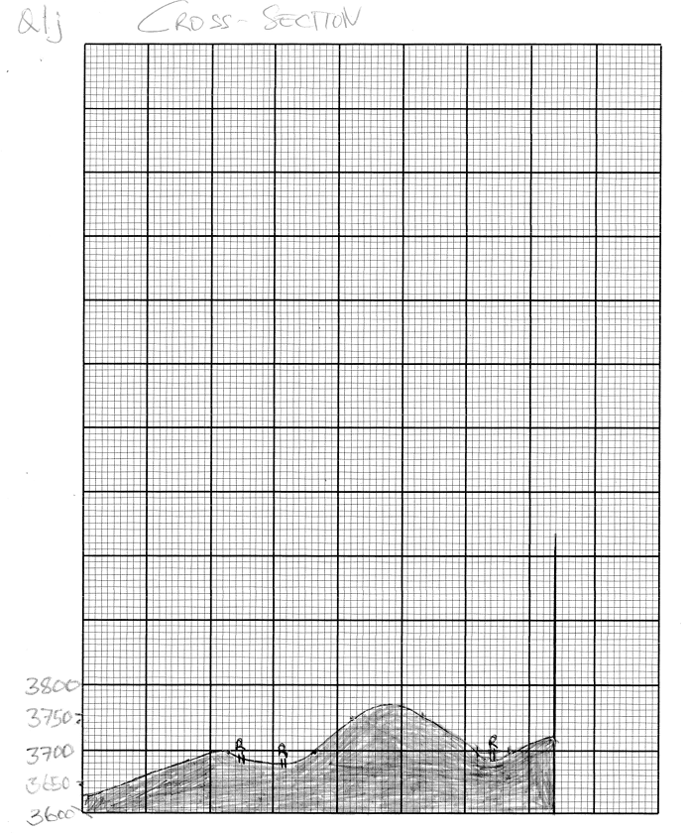

2. a. (i) -sudden movements of the earth
- vibrations in the lithosphere.
Any one point 2 marks
(ii) -the crustal rocks grind against each other as plates slip past one another.
-Rocks along a fault may lock together causing pressure to build up over time, and then the rocks may jerk free thereby releasing shock waves.
Any one point 2 marks
(iii) -mining
-nuclear testing
-road construction
- construction of large reservoirs
- movement of trains
Any two points 1 mark each
b. (i) -hail
-snow
-sleet
- frost
Any two points 1 mark each
(ii) -is wide spread
-is of a longer duration
-occurs in the mountain on the windward side
- occurs in all latitudes
Any two points 1 mark each
c. (i) B – Maritime Equatorial (mE) 1 mark
C – Continental Arctic (cA) 1 mark
(ii) A is cold while B is warm 1 mark
A is dry while B is very moist 1 mark
(iii) The region is cold and dry. There is no rising of moist air to condense and bring rain.

d. (i) - occluded (cold occluded ) front
Any one point 1 mark
(ii) 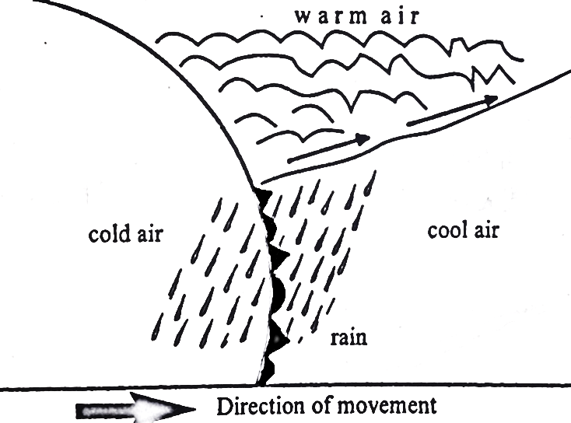 2 marks
(iii) 2 marks
e. (i) Force / weight exerted by air 1 mark
(ii) – temperature
- Altitude
- Amount of water vapour in the air /humidity
- The volume that the air takes up
- Rotation of the earth
Any one point 1 mark each
3. a (i) -Africa
-South America
Any 1 points 2 marks each
(ii) -Plate Tectonics theory explains what causes land masses to move.
1 mark
(iii) - tourism
- Fishing
- Agriculture
- Mining
- Transportation
- Lumbering
Any two points 1 mark each
(iv) -variations in thickness of sediments on the ocean floor
-variations in age of sediments on the ocean floor
-variations in age of rocks in the ocean floor
-magnetic variations on the ocean floor (palaeomagnetism)
Any two points 2 marks each

b. (i) -convergent plate boundary / destructive plate boundary)
Any 1 point 1 mark each
(ii) -trench
-volcanic mountains block mountains
-fold mountains
-earthquakes
- rift valley
Any two points 1 mark each
c. (i) -burning fossil fuels such as coal, natural gas and oil which accumulate in the atmosphere
-deforestation; when trees are cleared or burned, the carbon stored in the trees is released into the atmosphere as carbon dioxide, adding to the greenhouse effect.
-increased agricultural activities e.g. raising livestock e.g. cattle creates large quantities of carbon dioxide and methane emissions.
-urbanization tall buildings and fly overs may reduce the free flow of air, causing climate change.
-rapid population growth leads to greater consumption of food, water and energy putting a great stress on environment
Any two points 2 marks each
(ii) -enhanced financial and technical support to the agricultural communities so that indigenous and more drought tolerant food crops like cassava, millet, sorghum can be re-introduced into the farming system
-promoting irrigated agriculture by developing irrigation schemes along river basins, construction of water basins and pans
-addressing land degradation by building soil and stone bunds, creating grass strips and contour levelling as well as incorporating trees or hedgerows
-creating functional linkages with development partners for technological enterprise initiatives
-diversifying rural economies e.g. through value addition to the agricultural products and financial support for apiculture with the aim of reducing reliance on climate-sensitive agricultural practices.
-reducing reliance on centralized food system where commodity production is concentrated in a few locations that may be vulnerable to climate disruptions such as storm damage
-switching to new crops, seeds or agricultural practices can moderate the impacts on agriculture of changes in temperature and water availability
-improving weather and flood forecasting and communications can assist evacuation, relief and rehabilitation
Any two points 2 marks each.
(iii) -reduced agricultural land
-poverty and underdevelopment; Malawi is importing more food supplies than it is exporting to offset the increasingly serious effects of desertification
-depletion of water sources; loss of vegetation to desertification results in little rainfall
-loss of biodiversity; desertification contributes to the destruction of the habitats of animal and vegetable species and micro-organisms
-increased flooding; as protective plant cover disappears due to desertification
-increased illiteracy rates among women; women fail to attend to schools, job training or even leisure because they walk long distances to fetch water and collect firewood
-increased urbanization rates; many Malawians are leaving rural areas to urban centers to look for a better life
-climate change; increase in average temperatures and unpredictable rains are seriously affecting the country’s agriculture sector and this is affecting many lives
Any two points 2 marks each
4. a (i) - Equatorial
Any one point 1 mark each
(ii) - Tropical Evergreen
Any one point 1 mark
(iii) - Nigeria
- Gabon
- Central African Republic
- The Congo Basin
- Ghana
- Cameroon
- Coted Ivoire (Ivory coast)
Any two points 1 mark each
(iv) - Diseases and insects attack crop and animals
- Dense forests hinder communication
- Heavily leached soils affect Agriculture
- Dangerous wild animals attack people at livestock
Any two points 2 marks each
b. -prevents diseases like cholera and malaria
-environmental protection ie reduce pollution of water, soil and air
-aesthetic and tourism value -clean streets attract tourists and improve quality of life
-prevent flooding - clipped drains and blocked waterways can cause floods
Any two points 2 marks each
c.
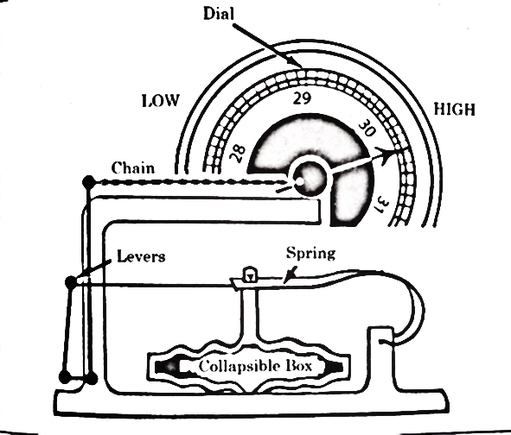
3 marks
The increase in air pressure on the outside of the box makes the lid to move, inwards. The chain is pulled to the right. This makes the indicator go to the right as well to register high pressure. When pressure falls, the box lid moves outward, and the indicator (pointer) moves to the left to show low pressure.
Any correct explanation 3 marks
d. (i) when igneous rock breaks into small particles, these particles are washed away and deposited in geosyncline where they are compacted and cemented to form sedimentary rock.
Any one point 4 marks
(ii) -because of cyclical deposition of sediments
Any correct answer 2 marks
e. clouds of great vertical extent
Any correct answer 1 mark
5. a. (i) - global warming can make some areas warmer and some areas drier
-more evaporation
-shift in wind pattern can bring droughts
-extreme weather like intense storms or prolonged droughts become more likely
Any correct answer 2 marks each

(ii) -an abundant source of warm moist air of temperature of about 27^{O}C near to sea surface
-air must be blowing inwards towards the centre and rising rapidly and nimbocumulus clouds must form to give heavy rains.
-there must be an inward flow of air in the upper level of the atmosphere
Any two correct answers 1 mark each
(iii) it is associated with
- calm weather,
- light winds,
- clear skies,
- no rain
Any correct answer 2 marks
(iv) - brings rainfall to Malawi
- marks on set of rainy season
Any two correct answers 1 mark each
b. (i) -Labrador ocean current
-North Atlantic Drift current
Any two correct answers 1 mark each
(ii) -it has lead to development of a major fishing ground because these areas have rich deposition of nutrients
-upwelling; deep nutrient-rich water rises
-fog is created and influence local climates
Any two correct answers 2 marks each
c. (i) - Savanna
Any correct answer 1 mark each
(ii) - deciduous trees
- - umbrella shaped
- - trees have long tap roots
- - trees have large trunks
-the vegetation is tall grass with short scattered trees which form a parkland or bush veld.
Any two correct answers 2 marks each
(iii) -Sudan - Botswana
-Malawi - Zimbabwe
-Kenya - Zambia
-South Africa - Mozambique
Any two correct answers 1 mark each
(iv) -droughts which can be serious most of the time.
-leaching which leads to formation of poor lateritic soils
-tsetse flies which do not favour animal rearing.
Any two correct answers 1 mark each.
(v) -to prevent water loss through transpiration.
Any one correct point 2 marks each

End of marking scheme

